
Oxford Diocesan Bucks Schools Trust (ODBST)
“ODBST - Empowering Lives, Flourishing Together”
Living ‘life in all its fullness’ (John 10:10)

Admissions (Primary) 2027/2028



Great Horwood Church of England School

ODBST Level 1 Statutory Policy: | ALL Schools require this policy with no changes allowed to core text. No changes are necessary to personalise this with school name and branding, as this is a Trust level policy for use, without change, by all schools, except where a school contact is required as identified in the content of the policy. LGBs will note adoption in LGB meetings. Review will take place at Trust level, and schools will be notified of updates and review dates as necessary.
Other related ODBST policies and procedures: | Guidance: The education of children out of their chronological year group.
Committee responsible: | Finance, Resources, Audit, Pay & Personnel
Approved by: | The ODBST Trust Board
Date Approved: | September 2025
Review Date: | September 2026

Contents
- Admission Arrangements 2027/28 ......................................................... Page 3
- Over subscription Arrangements ................................................................. Page 4
- Notes to the policy ................................................................................... Page 6
- Model in-year application Form .................................................................. Page 10

Admission Arrangements 2027/2028
Great Horwood Church of England School is part of the Oxford Diocesan Bucks Schools Trust (ODBST), who are the admissions authority for the school. The Board of Trustees works in partnership with the Local Governing Body of the school over the consultation and operation of the individual schools' admissions policy.
As a church school, we welcome applications from Christian families, and those of ‘all faiths and worldviews, whether religious or not’, without reference to ability or aptitude. We ask all parents applying for a place at our school to respect this ethos and its importance to the whole school community.

The ODBST and the Local Governing Committee (LGC) have made every effort to ensure that these arrangements comply with the School Admissions Code 2021 and all relevant legislation, including infant class sizes and equal opportunities.
In reviewing this policy, the ODBST has had regards to the Equality Act 2010. It is satisfied that no group with a protected characteristic will be unfairly disadvantaged.
There are 15 (the published admission number or PAN) places available for the Reception class in 2027.
There are 15 places (the published admission number or PAN) available for Year 3 in 2026. These places are in addition to the 15 places in Key Stage 1 and means that there are up to 30 places available in Years 4, 5 and 6.
The Trust consulted on Great Horwood Church of England School's admission policy in 2021-2022 for the 2023-2024 Admissions Policy.

Admission arrangements to the Reception Year in September 2027
Even if a child already attends the nursery class at Great Horwood CE School, a new application must be made to start Reception year group for the first time. Pupils are normally admitted at the beginning of the school year (1 September – 31 August) in which they reach their fifth birthday. Parents whose child was born between 1 September 2022 and 31 August 2023 may apply for them to be admitted to the Reception Year in September 2027. Parents of a child born between 1 September 2022 and 31 March 2023 may defer entry until their child reaches compulsory school age (the term beginning in January or April after his or her fifth birthday). The school will hold the deferred place for the child (provided it is taken up during the school year 2027/28), although children may benefit from starting at the beginning of the school year, rather than part way through it. For children born between 1 April 2023 and 31 August 2023 (summer born children) parents can defer the date that their child is admitted to school but not beyond the beginning of the final term of the school year. Parents should refer to DfE Guidance on requesting a delayed school start for children born in the summer: https://www.gov.uk/government/publications/summer-born-children-school-admission Summer born children: advice for parents. Until the child reaches compulsory school age, s/he may attend part-time. If parents wish to exercise this right, they should discuss detailed arrangements with the head teacher. Parents (see Note 1) wishing to apply for the Reception Year in September 2027 must complete the common application form provided by their home local authority (Buckinghamshire Council). The home LA is the LA in whose area the parents live at the time of the application. The form must be returned to that LA no later than 15 January 2027. Applications received after this date will normally only be considered after all those received on or before the cut-off date. Offers and refusals of places will be given to parents on 16 April 2027.
Procedures for applying to any school in Buckinghamshire are explained on Buckinghamshire County Council's website: https://www.buckinghamshire.gov.uk/schools-and-learning/schools-index/school-admissions/

Over-subscription criteria
Children with an Education, Health and Care (EHC) plan naming Great Horwood CE School will always be offered places. If there are fewer applications than places available, all children will be offered places. If there is greater demand for admission than there are places available, the following criteria will be applied in the order set out below:
1. Looked-after children and children who were previously looked after, including those children who appear to have been in state care outside England, but ceased to be so as a result of being adopted. (See Note 2)
2. Families who have exceptional medical or social needs that make it essential that their child attends Great Horwood CE School rather than any other. These needs must be fully supported by written evidence from the appropriate professional person involved with the family. (See Note 3)
3. Children with a normal home address in the catchment area (see note 4) and with a sibling (see note 6) on the roll of the school at the time of application or whose parent has accepted an offer of a place at the school and who is expected still to be in attendance at the time of entry to the school.
4. Children with a normal home address in the Great Horwood, Singleborough and Little Horwood catchment area.
5. Children attending a ‘linked primary’ school (Thornborough Infant School) at the time allocations are made.
6. Children with a normal home address outside the Great Horwood, Singleborough and Little Horwood catchment area and with a sibling on the roll of the school at the time of application or whose parent has accepted an offer of a place at the school and who is expected still to be in attendance at the time of entry to the school.
7. Other children.

Proximity of the child's home, as measured by the straight-line distance (see Note 6) between the home and the school with those living nearer being accorded the higher priority, will serve to differentiate between children in criteria 1 to 8 should the need arise. In the event that two distance measurements are identical, the school will use random allocation to decide which child should be offered the place. The process will be conducted in the presence of a person independent of the school.

All Other Admissions
In-year admissions or admissions at the beginning of school years other than the relevant age group may be made at any time; admission will depend on whether or not there are places available. Applications must be made directly to the school on a form available from the school.
If there is a vacancy, and there is no child on the relevant waiting list with a higher priority (according to the over-subscription criteria above), a place will be offered.
If there is a vacancy, and there is no child on the relevant waiting list with a higher priority (according to the over-subscription criteria 1-8 above), a place will be offered.
Admission outside normal age group
Requests from parents for places outside a normal age group will be considered carefully, eg for those previously educated abroad or those who have missed education due to ill health. A parent of a summer-born child who wishes their child to start in the autumn term following their 5th birthday (ie in the Reception Year rather than Year 1) should refer to: DfE Guidance: Making a request for admission out of the normal age group https://www.gov.uk/government/publications/summer-born-children-school-admission/making-a-request-for-admission-out-of-the-normal-age-group.
Each case will be considered on its own merits and circumstances and a decision made based on what is in the pupil’s best interests. It is recommended that parents discuss their wishes with the head teacher at the earliest opportunity. The governing board may ask relevant professionals for their opinion.
THERE IS NO RIGHT OF APPEAL WHERE A CHILD IS OFFERED A PLACE AT THE SCHOOL BUT NOT IN THEIR PARENT’S/CARER’S PREFERRED AGE GROUP.
Waiting Lists
The school maintains waiting lists for those children who are not offered a place. For those applying through the normal admissions round for entry, the Waiting List will be maintained from shortly following initial allocation in the year preceding the start of the academic year in September until 31 December following the start of the academic year in their Reception year.
The list will be re-ranked in accordance with the published oversubscription criteria each time that a name is added to or removed from the list.
Multiple births
In cases where there is one place available, and the next child on the list is a twin, triplet, etc., we would admit both twins (and all the children in the case of other multiple births) even if this meant exceeding the agreed admission number.

Fair Access
The school participates in the LA's Fair Access Protocol. Children qualifying under the Fair Access Protocol may be offered a place even if there are no places available in the relevant year group and also take priority for admission over any child on the waiting list.
Appeals
Any parent not offered a place for their child at their preferred school has the right of appeal to an independent appeals panel. Details of appeals arrangements are available from the school, including the date by which an appeal should be submitted. In the event of an unsuccessful appeal against non-admission to the school, the school will not consider any further application for a child in the same school year (1 September 2027 – 31 August 2028), unless there has been a material change in circumstances, for example a change of address which results in a move from outside the catchment area to inside it.
Right to Appeal
When the school informs a parent of a decision to refuse their child a place, it must include:
- The reason why admission was refused
- Information about the right to appeal
- The deadline for lodging an appeal
- The contact details for making an appeal
Parents must be informed that, if they wish to appeal, they must set out their grounds for appeal in writing. The school must not limit the grounds on which appeals can be made.
Further information
Parents who wish their children to attend the school are most welcome to visit. Arrangements can be made through contacting the school office on 01296 712622 or office@ghw.odbst.org
Notes to the admissions policy
The following are detailed notes referring to the definitions in use for this school's policy.
Note 1:
'Parent' is defined in law (The Education Act 1996) as either: a) any person who has 'parental responsibility' (defined in the Children Act 1989) for the child or young person; or b) any person who has care of the child or young person.

Note 2:
A 'looked-after child' is one in the care of a local authority or being provided with accommodation by a local authority in the exercise of its functions. Previously looked after children are children who have been adopted, subject to child arrangement orders or special guardianship orders. Adopted children are those for whom an adoption order is made under the Adoption Act 1976 (Section 12) or the Adoption and Children Act 2002 (Section 46). A 'child arrangements order' is one settling the arrangements to be made as to the person with whom the child is to live (Children Act 1989, Section 8, as amended by the Children and Families Act 2014, Section 14). A 'special guardianship order' is one appointing one or more individuals to be a child's special guardian/s (Children Act 1989, Section 14A).
Applications under this criterion must be accompanied by evidence to show that the child is looked after or was previously looked after (e.g. a copy of the adoption, child arrangements or special guardianship order). A 'looked-after child' includes any child who appears to have been in state care outside England if they were in the care of or were accommodated by a public authority, a religious organisation, or any other provider of care whose sole or main purpose is to benefit society.
Note 3:
Applications under criterion 2 (exceptional medical or social needs), must be supported by evidence from an independent professional person which clearly demonstrates why the school is the most suitable and must illustrate the difficulties that would be caused if the child had to attend another school. The person supplying the evidence should be a doctor, health visitor, social worker, etc. who is aware of the circumstances of the case. The school reserves the right to ask for further evidence or clarification where necessary and may seek the advice of appropriate professionals where necessary.
Note 4:
The home address is where the child normally lives. This will be where the parent or legal carer of the child lives with the child unless it is shown that the child is resident elsewhere with someone else who has legal care and control of them. The address should be a residential property that is owned, leased or rented by the child's parent/s or person with legal care and control of the child.
Where a child lives with parents with shared responsibility, each for part of a week or month, the address where the child lives will be determined having regard to a joint declaration from the parents stating the exact pattern of residence. If the residence is not split equally, then the relevant address used will be that at which the child spends the majority of the school week. Where there is an equal split or there is any doubt about residence, the home address will be assumed to be the address at which the child is registered with a GP.
Evidence of the normal home address may be requested in the form of a recent bill, for example, the most recent Council Tax bill, utility bill no more than three months old, a current TV licence, buildings and contents insurance, mortgage statement or rent book which shows the address concerned.
If a place at the school is offered, and it later becomes clear that the offer was made on fraudulent or misleading information (e.g. a false claim to living in the catchment area), and the school has denied a place to a child with a stronger claim, the school will withdraw the offer of a place. The offer can be withdrawn even after the child has started at the school.
If parents are moving house, evidence of the move will be requested when considering any application for a place. Documentary evidence in the form of a solicitor's letter to confirm exchange of contracts, or a rental agreement for at least a period of six months will be required.
If parents move house after the application has been made, but before any offer of a place has been made, the home LA must be informed.
An address of a second home with the main home being elsewhere will not be accepted. If there are two or more homes, or where a family is returning from elsewhere, evidence will be required of the main home. An allocation of a place based on an address which might be considered only temporary or where the address given is a second home will not be made.
An address where the child was resident other than with a parent or carer unless this was part of a fostering or formal care arrangement will not be accepted.
There are special arrangements for families of service personnel with a confirmed posting or crown servants returning from overseas. If the application is accompanied by an official letter that declares the relocation date, and if there is a place available, it will be offered even though there is not an intended address or the family is not yet living in the area.
Note 5:
'Sibling' means a natural brother or sister, half-brother or sister, adopted brother or sister, step-brother or sister, or the child of the parent's/carer's partner where the child for whom the school place is sought is living in the same family unit at the same address as that sibling. It is helpful if parents make it clear on the application form where the sibling has a different family name. Where there is more than one sibling at the school, only the youngest should be listed on the application form.
Note 6:
The straight line distance used to determine proximity of the home to the school will be measured by the LA's Geographical Information. They use straight line distance for admissions purposes. This is the distance from your child's normal home address and set out by the ordnance survey to the nearest open school gate available for pupils to use. The point the LA measure to at your child's address is determined by the ordnance survey ADDRESS-POINT which is an ordnance survey data product that provides a national grid coordinate and a unique reference for each postal address in Great Britain that is on the Royal Mail's address file. This is different to the shortest walking route which is used for transport purposes.
In the event that two distance measurements are identical, the school will use random allocation to decide which child should be offered the place. The process will be conducted in the presence of a person independent of the school
Catchment area for Great Horwood Church of England School
The school serves as a Key Stage 2 destination for pupils from local infant schools, providing an additional opportunity for children living within the catchment area to secure a place at the point of transfer and supporting continuity of education for local families.
EYFS and Key Stage 1 Catchment Area

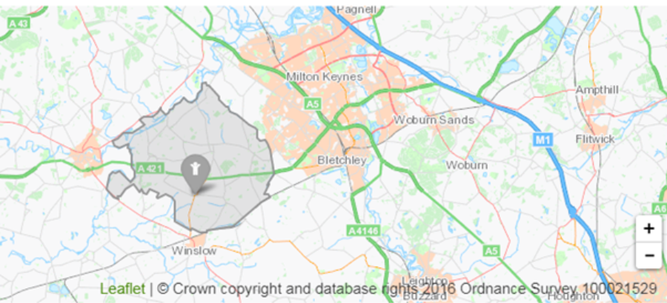

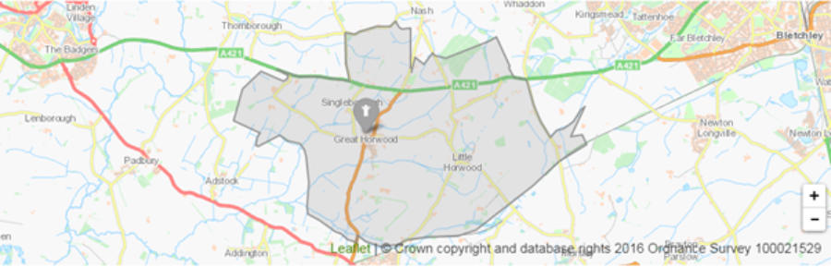
Key Stage 2 Catchment Area

In Year Application form

1 CHILD’S DETAILS

First name .................................

Middle name(s) .................................

Legal surname .................................

Sex Male/Female

Date of birth ___/___/______

Normal home address (the address and postcode at which the child normally lives). Please enclose address evidence.

.........................................................................

.........................................................................

Postcode ...................................

If moving home, please provide the new home address (the address at which the child will be living). Please enclose address evidence.

..........................................................................

..........................................................................

..........................................................................

Postcode ....................................

Name and address of current or most recent school

...........................................................................

...........................................................................

...........................................................................

Postcode .................................... Telephone number .......................................
2 YOUR DETAILS

Name of parent/carer living at home address above

Title ............ First name .................................... Surname ............................

Relationship to child ..........................................

Email address ...........................................................................

Daytime telephone number ..........................................

Mobile telephone number ..........................................

3 FURTHER INFORMATION

Date admission required ___/___/______

Does the child have any brothers or sisters attending the school? Yes/No

If ‘Yes’, please give name of the youngest sibling attending the school

...........................................................................

Does the child have an EHC (Education & Health Care Plan) Yes/No

If ‘Yes’, which Local Authority maintains this Plan? ........................................

Is the child ‘looked after’ by a Local Authority or was s/he previously ‘looked after’? Yes/No

If ‘Yes’, please provide details.

[Any other questions needed to apply the school’s oversubscription rules – e.g. disability, medical/social needs, previous sibling attendance, etc.]

4 DECLARATION

I certify that I have parental responsibility for the child named in Section 1 above and that this application has the agreement of any other parent/carer with parental responsibility for the child.

I have read the school’s admission policy.

I confirm that the information I have provided is to the best of my knowledge correct and up to date. I understand that if I give any false or deliberately misleading information on this form and/or any supporting papers or withhold any relevant information, this may lead to the withdrawal of an offer of a place at the school for my child.

I authorise the school to contact my child’s previous school.

Signature of parent/carer .......................................................................

Date: ___/___/______
Supplementary Information Form attached yes/no (delete as appropriate)

